**WIL PROTOTYPES**:

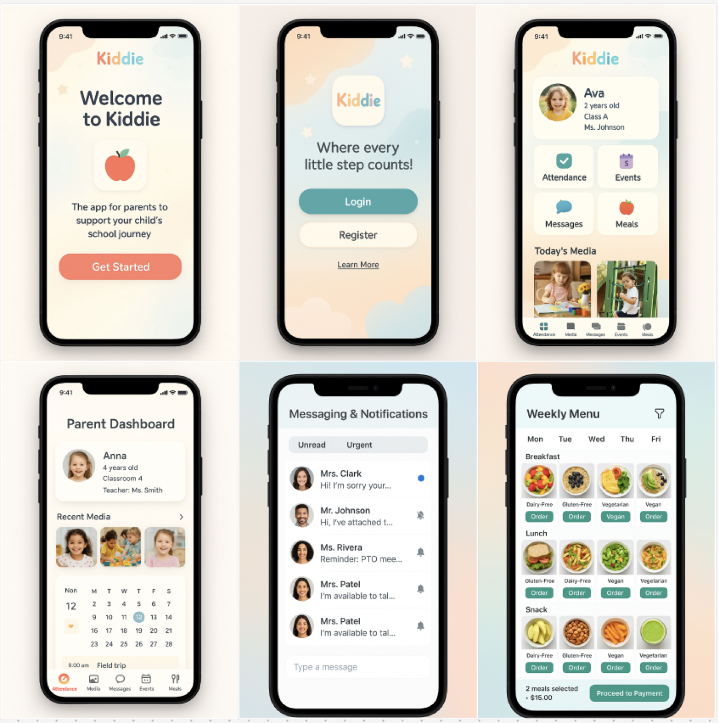

Link: <https://www.figma.com/board/1QPRrHKb7BPvV7CuLnOxg0/WIL-MOCKUPS?node-id=0-1&p=f&t=vkbVJA8Oux8yAju1-0>